**School of Computing**

**Database Systems (COM106 – CRN 19566)**

**SUPPLEMENTARY PRACTICAL EXAMINATION – ANSWER TEMPLATE**

**INSTRUCTIONS**

**Please read this section carefully**

* Rename and save this file using the file format ***Surname_Initial_PracticalExam*** (e.g. ***Corr_P_ PracticalExam***).
* You should paste screen shots from Microsoft SQL Server 2017 into the appropriate template spaces below, as directed in the Supplementary Practical Examination paper.
* When you have completed the Supplementary Practical Examination, upload a completed copy of this document to the ***Supplementary Practical Exam*** dropbox in the Supplementary Coursework folder on Blackboard.

**Examples of the Screenshots that should be Included in the Spaces Provided.**

* **For Creation, Alter and Insertion Statements – show the statement and the associated message**

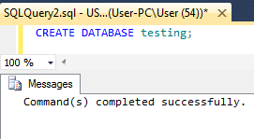

Screenshots must be pasted as a **single image** showing both the SQL statement **AND** the corresponding messages.

If the messages information is not included (or is included as a separate image) it will be taken as evidence that your statement did not execute correctly

**When pasting screenshots,  
please ensure that the text in the image is large enough to be easily read**

* **For SQL Queries – show the query and the associated results table**

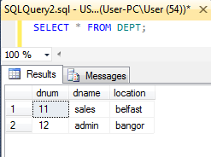

Screenshots must be pasted as a **single image** showing **BOTH** the SQL statement **AND** the corresponding results.

If the results information is not included (or is included as a separate image) it will be taken as evidence that your statement did not execute correctly

**SECTION A (30 Marks – 30% of exam)**

**CREATE DATABASE** statement & Use statement

**ASSUMPTIONS** made when deciding on appropriate datatypes

Phone numbers are usually a maximum length of 11. 15 was given for spaces and extra characters such as + for area codes, as well as making the type varchar so any starting 0 and symbols would be stored.   
  
The maximum length for any name was given to be no more than 100 characters, this allowed all data to be inserted without any truncated field errors.

The data type and length of the prize money was set to be numeric as this data type can handle decimal level precision, the first parameter determines the maximum length of the number as a string length with the decimal precision included. It was set to be no more than 15 characters, and 2 decimal places, as you can not pay less than 1 pence precision, this number max was then 100000000000.00 (one hundred billion, 15 characters in length).

Age was set to integer as we often don’t refer to animals in precise levels of age, whole years is accurate enough as the data displayed.

**CREATE TABLE** statement used to create the **TRAINER** table

**CREATE TABLE** statement used to create the **HORSE** table

**ALTER TABLE** statement used to add referential integrity

**Two INSERT** statements inserting **your chosen record** to each table (in correct referential integrity order).

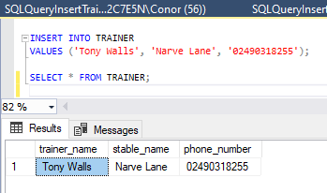

Display the **TRAINER** table (using **SELECT * FROM** …. ) populated with appropriate data – after running the insert statements provided in files **INSERT1** and **INSERT2**.

Display the **HORSE** table (using **SELECT * FROM** …. ) populated with appropriate data – after running the insert statements provided in files **INSERT1** and **INSERT2**.

**SECTION B (30 Marks – 30% of exam)**

1) Get the horse name and owner name of ‘chestnut’ coloured horses over the age of 12.

**2)** Create a view called ‘Under_Five’ of horse name, owner name and age of horses under the age of 5..

Display the view (using **SELECT * FROM** Under_Five;).

**3)** Change the phone number of the trainer named ‘Willie Mullins' to 'WITHHELD'.

Display the **TRAINER** table to show the change.

**SECTION C (50 Marks – 40% of exam)**

**1.a)** Get the type and description of faults where the fault type contains the letters ‘Server’.

**1.b)** Get the fault id and the name of the staff member assigned to deal with faults of type ‘Printer’.

**1.c)** Using an outer join approach, list the skill_id of all skills where there are no qualified members of staff.

**2.** State the natural language query that the following SQL code answers.

It gets the staff id and the number of qualifications they have.

SELECT a.skill_id, b.qualification

FROM SKILL a

FULL OUTER JOIN STAFF_EXPERTISE b ON a.skill_id=b.skill_id

WHERE b.qualification IS NULL

ORDER BY a.skill_id ASC;

**3.a)** A meaningful SQL single table query with a **GROUP BY** clause and a valid **HAVING** clause.

**3.b)** The natural language query that the SQL query developed in question 3.a) answers.

It counts the number of qualifications per staff member using the staff id as unique identifier by staff id groups the unique identifier and the having clause performs a where like criteria but based on the grouped data.

The subquery is then linked with an inner join to only match on the data results its returns to the tec staff table to get access to the staff members name, a full outer join here ignores the matched inner criteria and tried to display all results from the right table (tec staff) meaning the count criteria was pointless, inner matched only what the subquery returned.

Alias AS clauses were used to rename columns for readability.

SELECT "NumberOfQaulifications", "name", "TEC_STAFF".staff_id FROM (

SELECT COUNT(qualification) AS "NumberOfQaulifications", "staff_id" AS "STAFF_ID"

FROM STAFF_EXPERTISE

GROUP BY "STAFF_ID"

HAVING COUNT(qualification) > 1

) AS subqry

INNER JOIN TEC_STAFF ON subqry."STAFF_ID"=TEC_STAFF."staff_id";